APPENDIX A

SNAPSHOTS
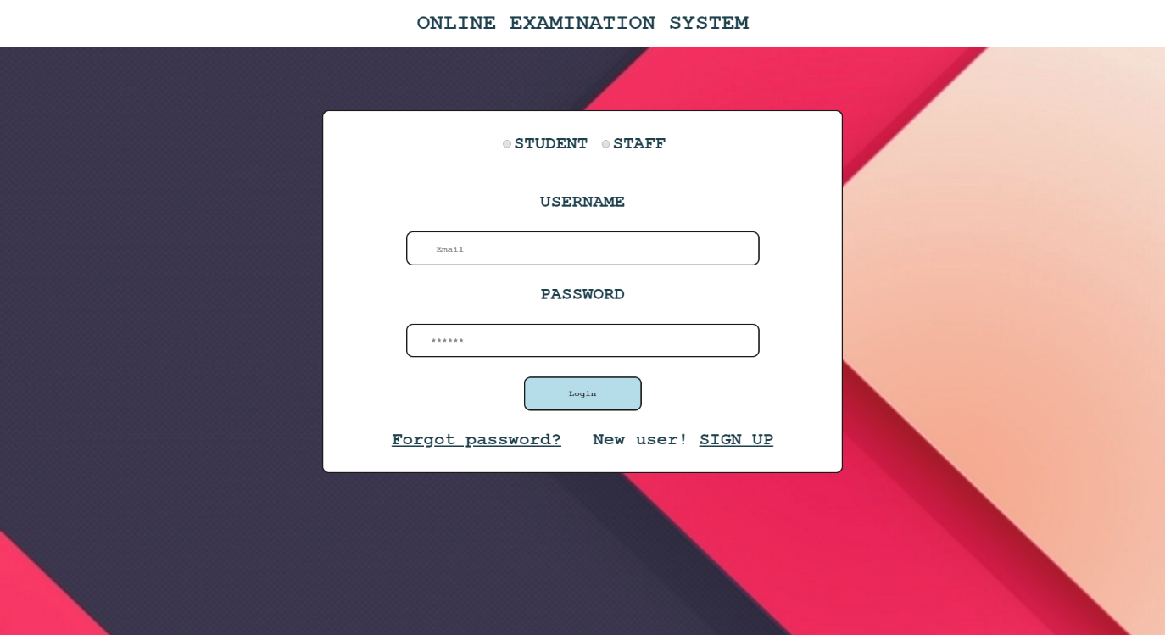

Snapshot 1: Start page of the project

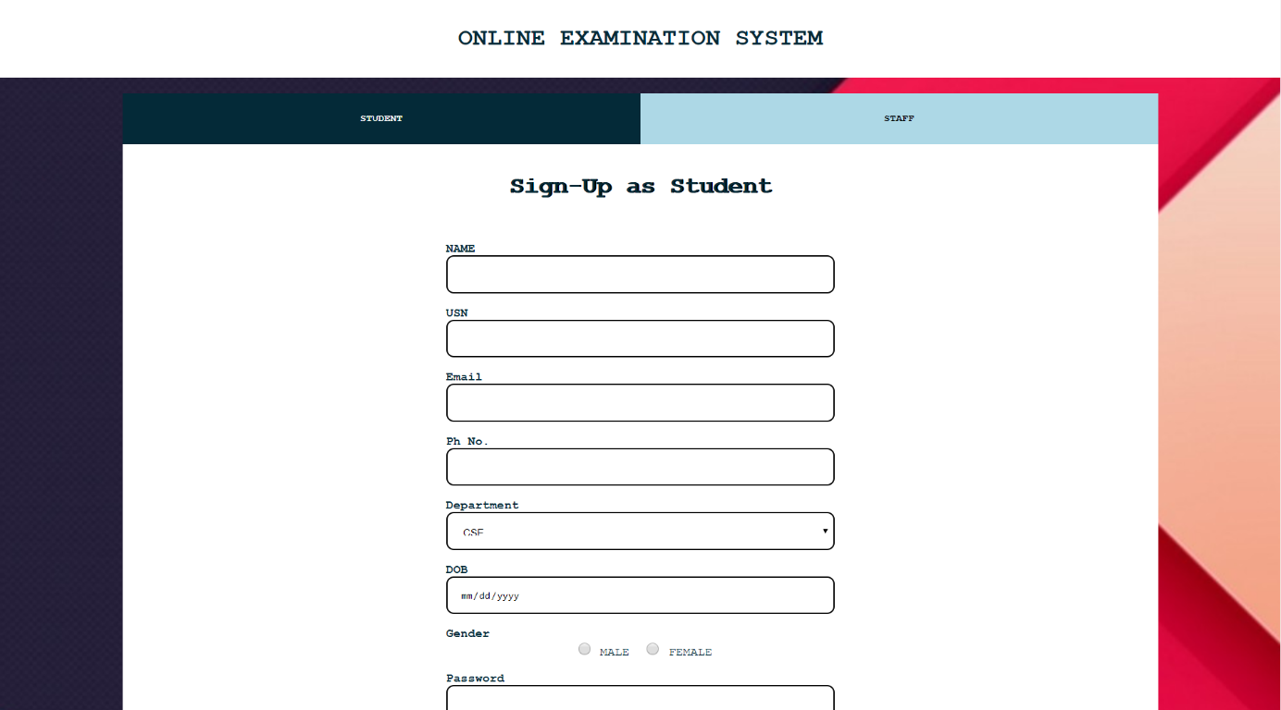

Snapshot 2: Sign Up Page

Dept., of CS&E, SVIT 2019-20 15
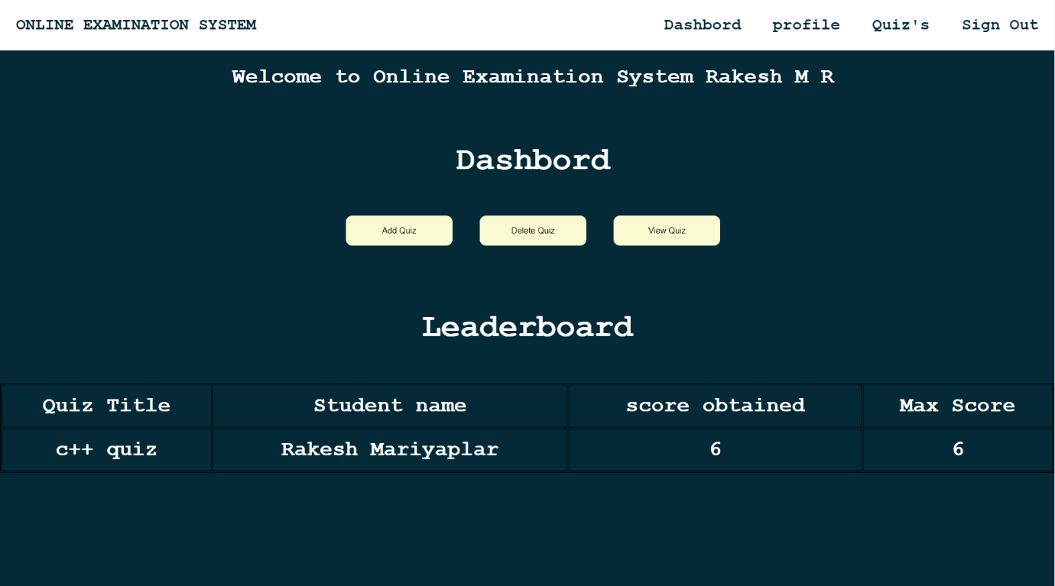

Snapshot 2: Dashboard for Staff

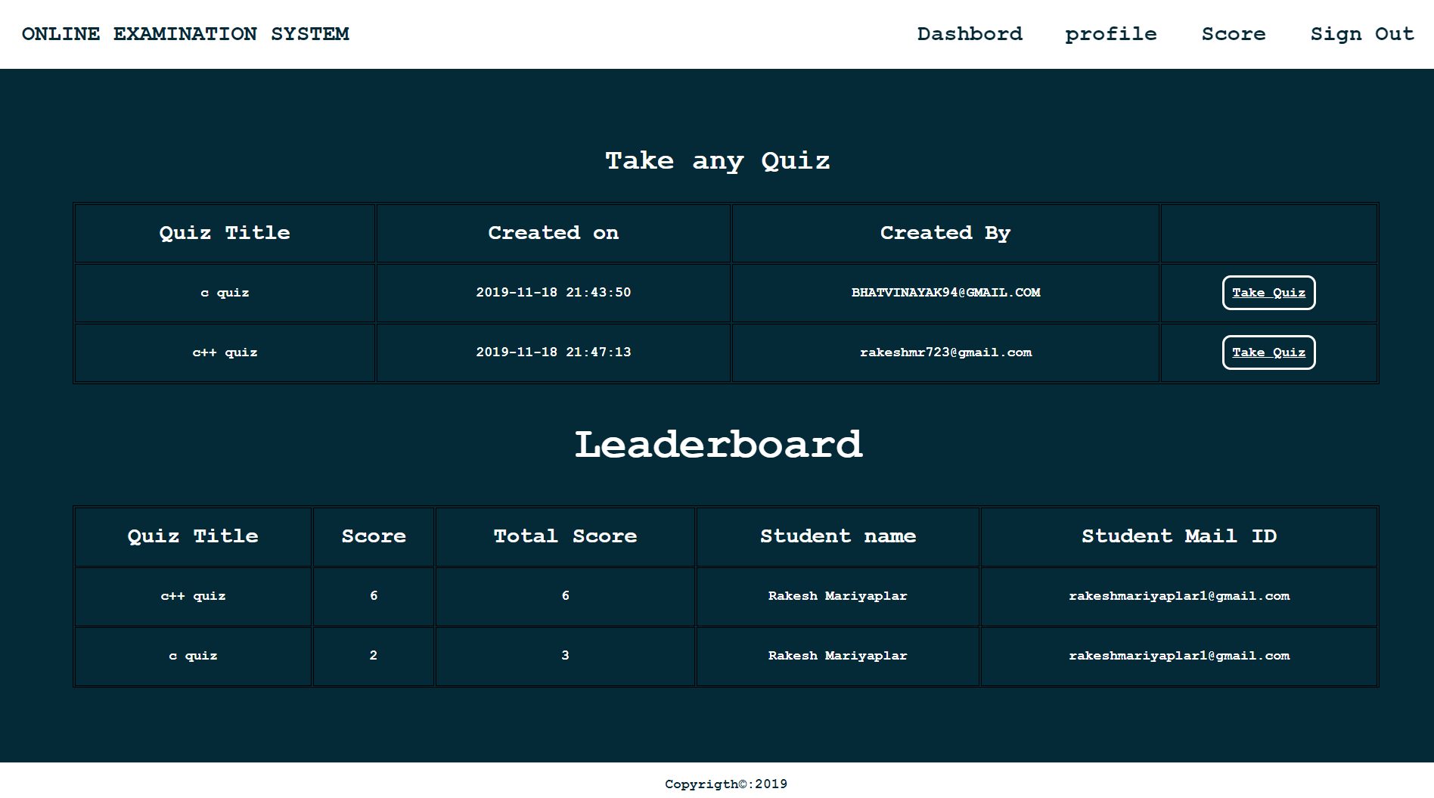

Snapshot 3: Dashboard for Students

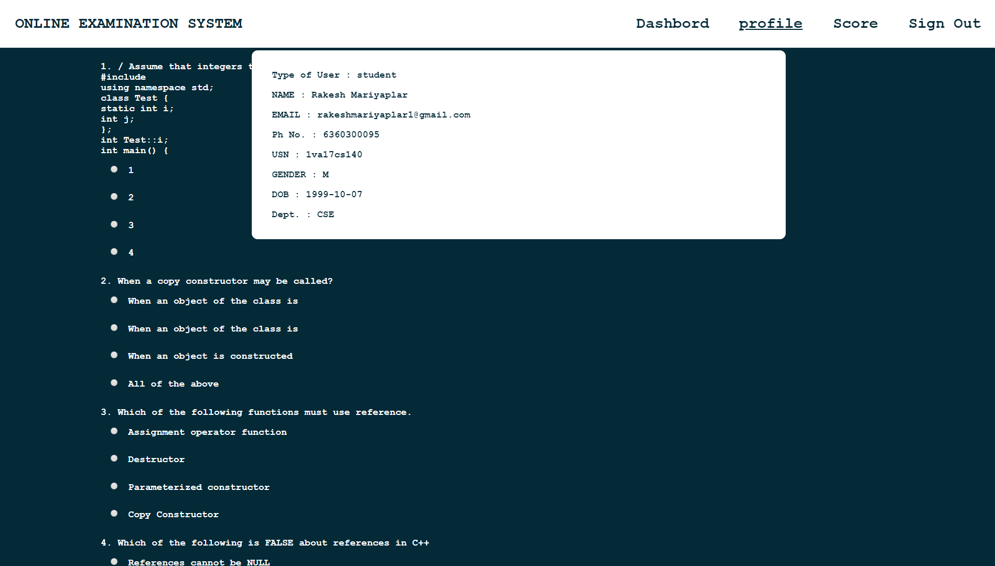

Snapshot 4: Profile view of Student

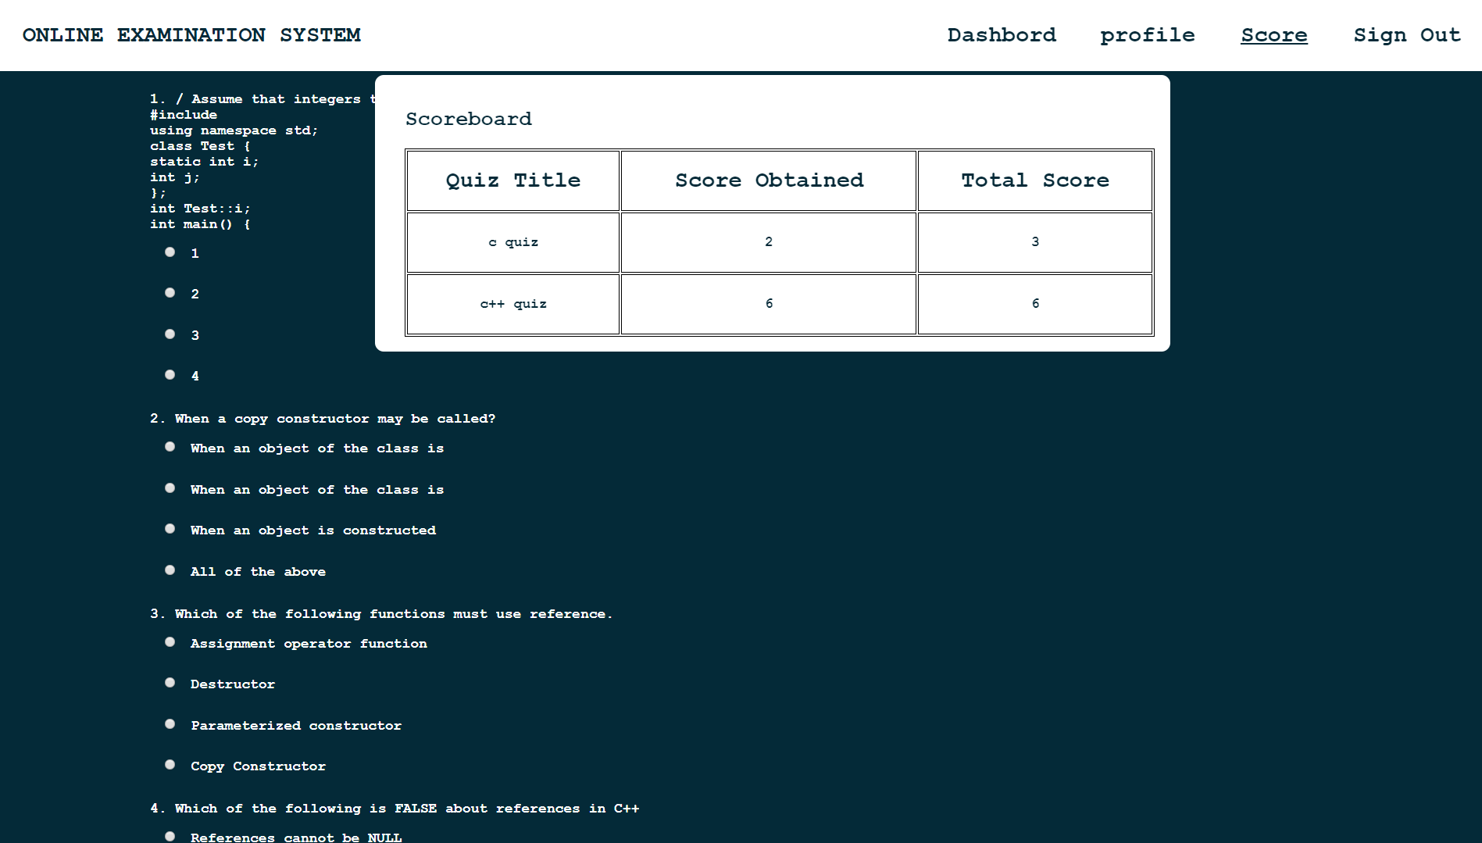

Snapshot 5: Scoreboard of user
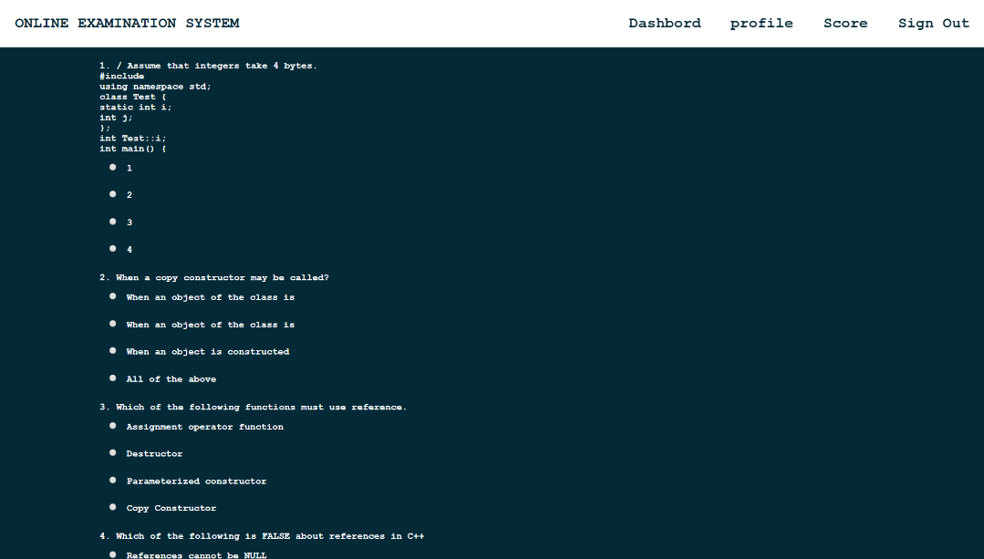

Snapshot 6: Taking Quiz by Student

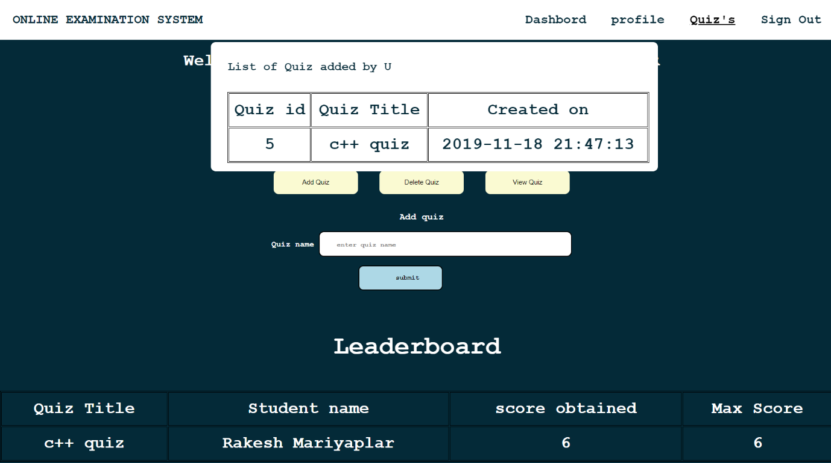

Snapshot 7: Quiz Added by The Staff

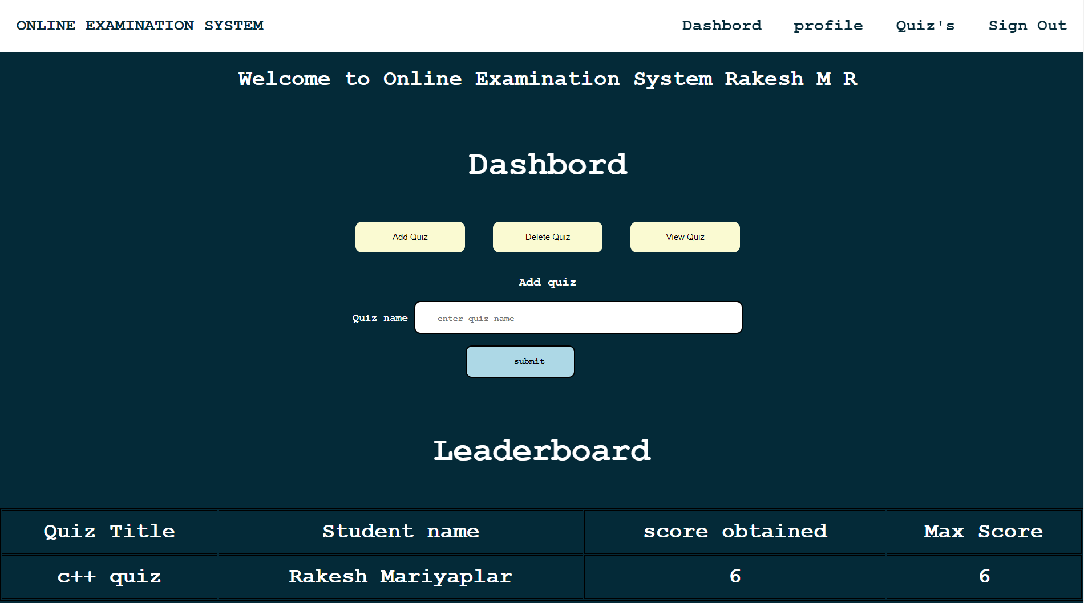

Snapshot 8: Adding quiz page by staff

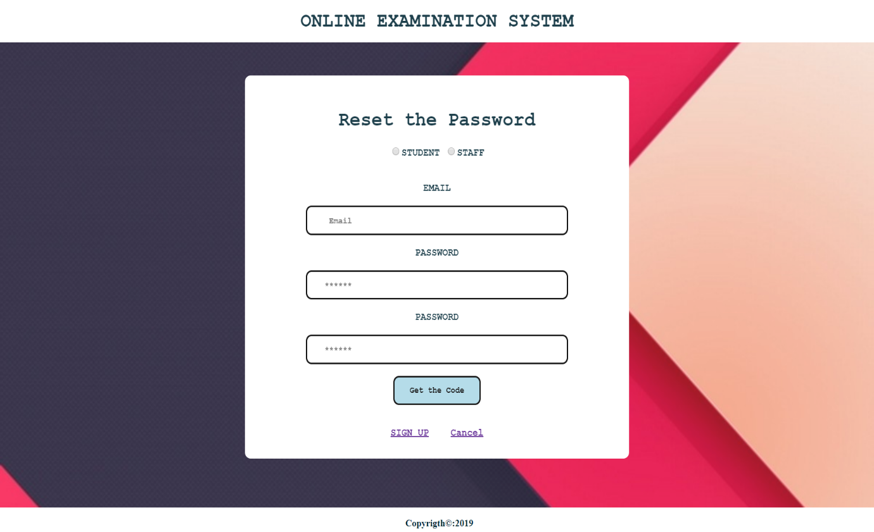

Snapshot 9: Request for security code

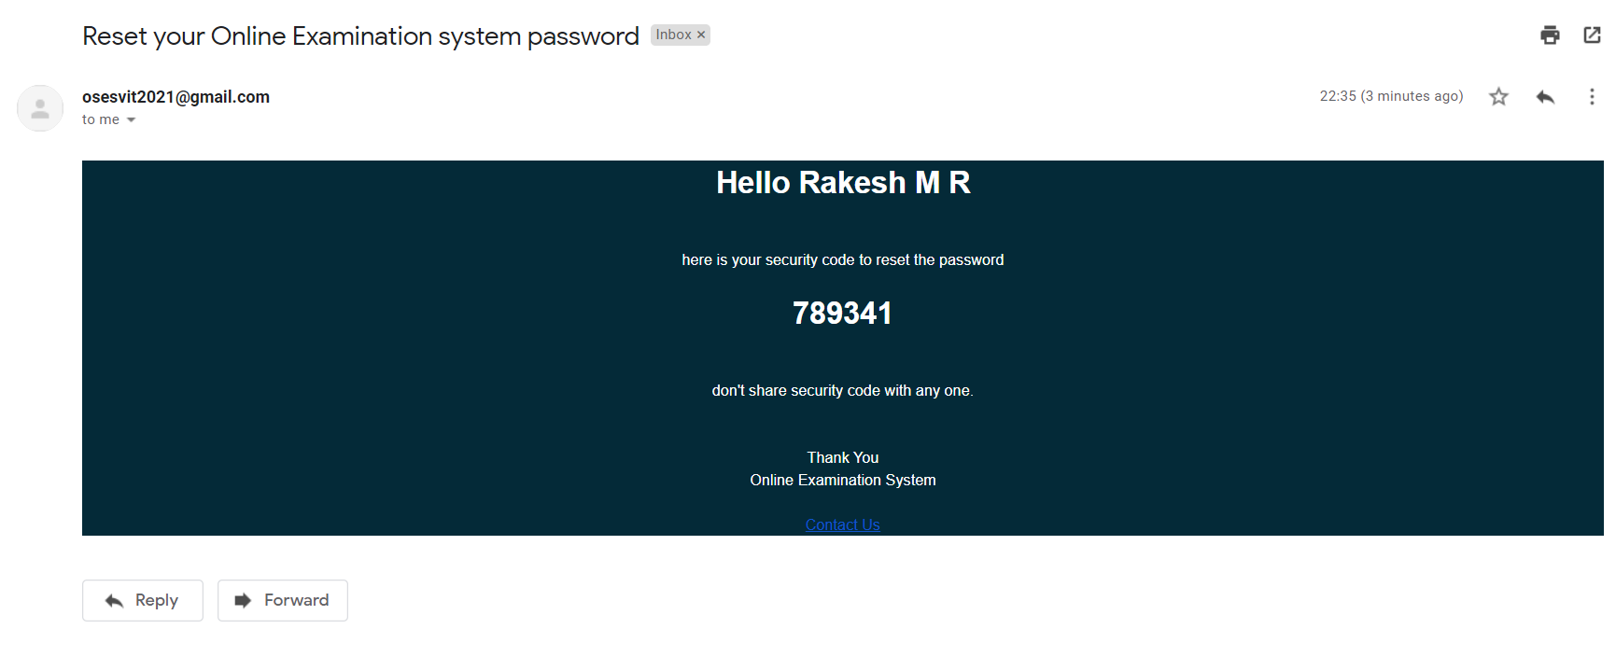
Snapshot 10: mail received by user with security code

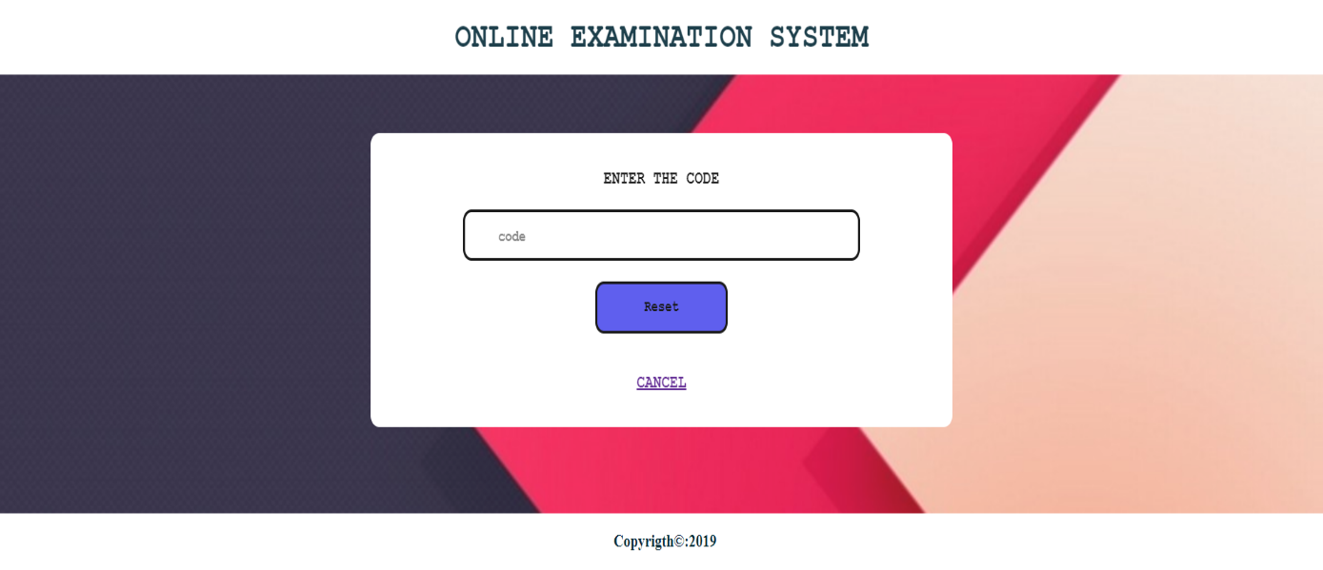

Snapshot 11: verifying the security code and update password

